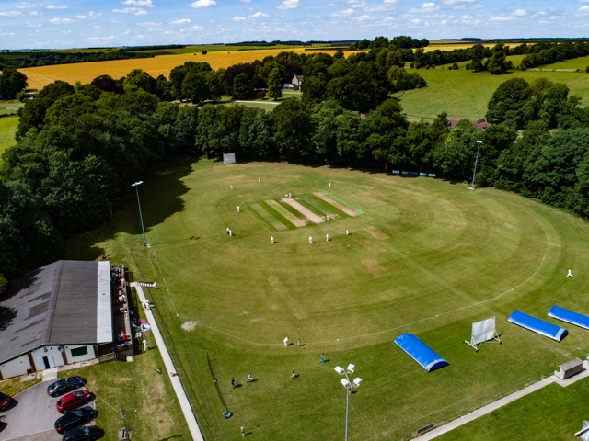
1st Xl Hants County 1  The 1st Xl start the 2018 season in Hampshire County Division 1 with Will Sleeman continuing as captain this season.  Will is a batsman who has been a stalwart of the first team for many years now after coming through the youth set up.  Due to circumstances the 1st Xl will only have one preseason friendly away to Chippenham on Saturday the 28th of April before doing battle in the first round of the Village Knockout, this also being away at Charlton Down on Sunday the 29th of April.  Promoted to The Southern Premier League and is an ongoing ambition for the club.  2017 results across all formats were P21 W10 L9 Abandoned 2 | 2nd Xl Hants RDNW1  The 2nd Xl start the 2018 season in Regional North West Division 1 and Chris Newbury has the task of balancing the middle team put out by the Shrews.  The aims of the 2’s this year is to push to try and close the gap to the first team.  The 2nd Xl planned to kick off the 2018 preseason with a trip to face Thames Ditton in Surrey on the 14th of April 2018, however due to the early spring weather the game was called off a few days earlier.  The 2nd Xl will also have to make to with a single preseason friendly hosting Chippenham 2s at Tidworth’s Garrison pitch on Saturday the 28th of April  2017 results across all formats were P17 W9 L5 Abandoned 3 | 3rd Xl Hants RDNW3  The 3rd Xl start the 2018 season in Regional North West Division 3 with Jim Nicholson looking to continue last season’s aim of developing and encouraging the next generation of Shrews into adult cricket alongside the not so young.  With any luck the Shews thirds can win a game or two along the way while maintaining the fun.  RDNW3 has 9 teams playing home and away to contest the league this season. For the 20018 season RDNW3 is 40 overs a side, starting at 1pm.  The 3s will have a preseason friendly away at Marden Cricket Club near Upavon on Sunday the 29th of April.  2017 results were P17 W3 L10 Abandoned 4
Shrews Player Of The Month
This month’s player of the month is Anonymous, who is a right-handed batsman who also keeps wicket. Anonymous is a little camera shy and you will be hard pressed to find a picture of him in print. Anonymous is a sociable person however who’s bar tab is bigger than he is. His favorite piece of equipment appears to be the heavy roller. Anonymous can recognised by his khaki shorts and usually having a fag on the go. No prizes for guessing his identity.
Tues Xl  Following on from winning the Old Sarum Invitational League Cup in 2016.  The Shrews followed this up by winning the league title in 2017 and going out at the semifinal stage of the Cup falling just short of what would have been a memorable double.  2018 is an exciting year with a league title to defend, another competing in a shiny new blue T20 Kit.  Shrewton Cricket Club  2017 Sarum Invitational League Champions | Wed Xl  This Team in a new venture for The Shrews and will compete in the Salisbury District Wednesday Night League.  Given the experiences of many of the current first team, it has been decided that this team will be a youth development side who will complete in Division 2 of the league with FOSS, Laverstock and Ford and Salisbury Civil Service.  Kieran Jones will skipper the side in addition to his role as coach of the U15/13s as well as bringing on the next generation of Shrews it will give more members a chance to play in the T20 format. | Sun Xl  Another packed season is in store for the Sunday Xl with more reverse home and away fixtures with local clubs around Wiltshire and beyond.  Just keep an eye on the What’s on button via the club’s website to check out where The Shrews will be playing in 2018.  Chris Newbury will skipper of the side on the field.  In addition to the flagship Twiston Davis match the club will host a centenary celebration of Cecil Chubb linking the village with Stonehenge in July.
Under 15s/13s  Following the unfortunate circumstances of last season and the colts getting that little bit older, it has been decided to enter the side in the Kennet U15/13 league.  This should enable a lot more games this year for the team. Kieran Jones in again coaching this team for 2018.  The fixtures for the U15/13s have been published on the relevant page of the junior section of the website | Under 11s  The U11s had some fine results in 2017 beating Heytesbury & Sutton Veny, the league winners in a nail biting last over away from home.  This season the U11s will also move to the Kennett League as well as palying in the Wilshire league. Rich Barnett will Coach this side again. With commitments in 2 leagues it will give the U11s lots of games to enjoy. Here’s to another successful year for the U11s.  The fixtures for the U11s have been published on the relevant page of the junior section of the website | Under 9s  The U9s are again going to be attending various festivals all around Wiltshire.  The club will again be hosting its own Festival on Sunday the 17th of June 2018.Shrewton has been selected to be a club trialing a new concept of playing U9s cricket with the fine details still to be confirmed. Keep an eye out for other festivals  Stu Cruse will be looking after the U9s again.  All the festivals have now been published on the relevant page of the junior section of the website
Got a bright idea

Have any thoughts on how we can improve the club for its members. Don’t just keep it to yourself let the committee know and your idea can be discussed at the next club committee meeting. Basic concepts are fine but ideas with a little planning or conceptual vision behind them would be great. Just contact the Club Secretary with the details via email or the contact us tab on the club website.

